Business Plan

for:

The Steelers Project
Fort Wayne, IN

Contact:

Matthew Garnett
Founder &
Chief Executive Officer

Mobile- 518-232-9489
Email- matthewgarnett@thesteelersproject.org

DISCLOSURES

No offering is made or intended by this document. Any offering of interests in Men of Steel will be made only in compliance with the applicable Federal and State securities laws.

This document includes confidential and proprietary information of and regarding Men of Steel. This document is provided for informational purposes only. You may not use this document except for informational purposes, and you may not reproduce this document in whole or in part, or divulge or disseminate any of its contents without the prior written consent of Men of Steel.

By accepting this document, you agree to be bound by these restrictions and limitations.

TABLE OF CONTENTS

Table of Contents
DISCLOSURES 2
TABLE OF CONTENTS 3
EXECUTIVE SUMMARY 4
BUSINESS & INDUSTRY OVERVIEW 5
FUNDAMENTALS 5
VISION 6
CUSTOMERS (Also, see Market Analysis Section) 6
SERVICES 6
VALUE PROPOSITION 6
MARKET ANALYSIS & COMPETITION 8
MARKET SIZE 8
MARKET TRENDS 9
COMPETITION 10
SALES AND MARKETING PLAN 12
SALES 12
MARKETING 13
OPERATING PLAN 16
OWNERSHIP & MANAGEMENT PLAN 19
MANAGEMENT 19
FINANCIAL PLAN 21
EXIT STRATEGY 21
KEY METRICS 21
APPENDIX A 22

EXECUTIVE SUMMARY

Management Team
Mr. Matthew Garnett, our Founder, is an experienced truck driver with extensive management and leadership experience across several industries, including customer service, operations management, and spiritual training and motivation.

Customer Problem
There are too many men in the USA stuck in the stifling cycle of crime, and crushing poverty. These men lack the opportunities and training to independently remove themselves from these vicious cycles. At the same time, there is a growing shortage of skilled truck driving professionals across North America.

Products & Services
We provide truck driving training to our students and shipping services to our customers.

Target Market
We focus on our truck-driver students as our ultimate customers. If we serve them well and train them properly, we help them create a positive influence in their lives and the communities in which they live. As we build and develop motivated and well-trained driver-partners we will seek local shipping customers to hire Men of Steel to fulfill their requirements, which will provide the revenue stream to support the training operation, e.g., school.
Business Model
Our revenue model to support our students and operate our Driving School is two-pronged:

- Grants, scholarships, and donations from the local community;
- Contract revenue from local shippers for our trucking services.

Sales & Marketing Strategy
The mission of Men of Steel is to offer our prospective Driver-Partners “free” training to become actual truck drivers. We will seek available job-training funds and other grants and donations from nearby public and private sources to support each student.

Importantly, we will work with local shippers to hire us and our students-in-training as an additional and key source of revenue.

Competitors
Men of Steel will compete with traditional truck driving schools but employ a much more involved approach with our students and provide a living wage to them while in training.

BUSINESS & INDUSTRY OVERVIEW

FUNDAMENTALS

Men of Steel is an Indiana-based social impact startup formed for the purpose of launching and operating a trucking company that finds, hires, and trains a certain segment of people as partners to, firstly, provide an alternative and more productive occupational path for them and, secondly to provide a valuable and profitable service to its customers.

The Founder and CEO of Men of Steel is Mr. Matthew Garnett. Mr. Garnett is an experienced truck driver, operational manager, and ordained minister with over a decade of experience in each. He is a devoted “server of people” with significant leadership in customer service and religious ministering. (See Management section below.) It is on this unique and complementary foundation that he and his team will build the venture into a successful operation benefiting the partners, the customers, and the financial backers of Men of Steel.

Men of Steel Overview-

Men of Steel is on a mission to assist the building of a productive path forward for parolees and underprivileged youth stuck in the toxic cycle of poverty, violence, and addiction. We do this by providing an entrée into the trucking business, which is certainly demanding but relatively easy to enter, to start generating a decent income and rebuilding character and integrity in these people, our partners. Our operating structure provides and a path forward to a clean and productive new life, while simultaneously providing hope and inspiration to our partners and their loved ones, and others who may find themselves in a similar cycle.

With our unique partner base and social mission, we will attract the capital and operational support needed to serve numerous paying customers who will be highly motivated to hire Men of Steel because of the positive impact we can make together.

Men of Steel, at its core, is a transformational driver training company with a unique hiring and training model that serves those who lack a second chance at change. Unlike a truck driving school that charges tuition for training drivers, Men of Steel actually pays its drivers-in-training a reasonable wage while providing life skills training to maximize their chances of success on this new path of life. We do this by training our drivers on-the-job for hauling actual shipments for real paying customers. (See more details in the Operating Plan below.)

As a high-level description of our target market, we will first seek to build trust with our target partners in our home base of Fort Wayne, IN. We will make regular outbound contact with local correctional offices and other organizations that work with people in financial crisis and connect with our potential partners through them. (See more details in the Market Analysis and Marketing Plan below.)

Men of Steel is built on the following fundamental beliefs:

- Hope: We believe that for anyone, but especially to those with heavy pasts and burdensome consequences, a second chance is the key to creating hope which can be the fuel to push one forward to getting closer to reaching their full potential. Hope is what we deliver to our partners while we make deliveries for our customers.
- Quality: Though we have a social impact element to our work at Men of Steel, we recognize that we must deliver a high-quality service and professionalism worthy of both our customers and our partners. This commitment to quality sets us apart from our competition and motivates our customers and partners to work with us for the long-term, which enables us to create a sustainable culture of excellence.
- Innovation: There is a tangible lack of skilled workers in the U.S. today which affects economic output across the country. Our innovative approach to filling this gap, while re-building men with challenging backgrounds, is where Men of Steel will stand out for our business model that balances quality services and catalytic compassion.

VISION

Men of Steel provides transformative truck driver training and life-changing support for former inmates and economically disadvantaged people as our driver-partners.

CUSTOMERS (Also, see Market Analysis Section)

Our primary customer is actually the student we train as truckers and develop as people.

With this primary customer base properly served, we can then focus on providing our trucking services to direct shippers.

SERVICES

Men of Steel simply offers one service: safe and reliable truck drivers.

We are proud of our drivers and endeavor to highlight to our customers the positive impact they can make on these drivers by hiring Men of Steel.

VALUE PROPOSITION

Men of Steel provides reliable freight services executed by our well-trained drivers maximizing their second chance at a productive life by completing our breakthrough training program.

THE ASK

- $400,000 Unsecured Loan or Grant
- If loan, consider convertible note instrument with Valuation Cap, Discount, and Interest Rate TBD.

MARKET ANALYSIS & COMPETITION

MARKET SIZE

First Market-Our truck-driver students are our ultimate customers. If we serve them well and train them properly, we help them create a positive influence in their lives and the communities in which they live. Identifying the market of potential driver-partners is key to our success.
Second Market-As we build and develop motivated and well-trained driver-partners we will seek local shipping customers to hire Men of Steel to fulfill their requirements, which will provide the revenue stream to support the training operation, e.g., school. Our Founder and CEO, Matthew Garnett, will use his existing deep network in Ft. Wayne with shippers to strategically build this market as a reliable source of income to support our training of driver-partners.

For both Markets we will start in Ft. Wayne, IN and then look to expand to Detroit and Chicago markets as is prudent and possible. At that time a proper market analysis will be conducted to better understand the specific dynamics of each market but there is no question that the size of both markets is more than adequate to support an expansion.

First Market (Driver-Partners) Data-
According to a 2018 report (the latest report currently available) by the nonprofit Prison Policy Initiative, there were 8,026 persons in Indiana on parole and 106,578 persons on probation.

A closer look at the data from a 2019 Allen County Community Corrections and Allen Country Adult Probation annual report reveals that in the Fort Wayne area (Allen County) nearly 5,000 people were on supervised probation. Of this group 59% were employed when they started the program and that percentage increased to 82% while in the program.

These data confirm ample market size for us to start here and underscores that the Adult Probation agency recognizes the need for, and benefit of, employment for those in the probation/parole program. This recognition will certainly improve the chances that our pitch for Men of Steel in Indiana will be heard and subsequently accepted.

From the same Prison Policy report mentioned above, we simply note below that our future expansion markets, Chicago and Detroit, represent significant opportunities to grow and help positively impact thousands of lives with our novel model.

Market | Parole | Vs. Ft. Wayne | Probation | Vs. Ft. Wayne
Detroit (MI) | 17,141 | +213% | 172,400 | +162%
Chicago (IL) | 28,167 | +351% | 112,174 | +105%

MARKET TRENDS

We are excited to be launching Men of Steel at a time when the trucking and logistics industries are booming nationally and in our home state of operations, Indiana, as we see an improvement in the COVID pandemic. Simultaneously, there is a national shortage of truck drivers. This confluence of trends illustrates the immediate and significant opportunity for Men of Steel.

National Trends-

A very recent report (May 2021) by Azuga quotes the FTR Transportation Intelligence estimate of a 6% growth rate in 2021 and even more expected growth in 2022 and beyond.

This same report also notes that there is an expected shortage of more than 100,000 drivers in 2023 across the USA.

The President and CEO of the American Trucking Association (ATA) commented in October 2021, that the truck driver shortage is at a record high and 30% higher than before the pandemic. He went on to say:

"It doesn't matter if it's a port in LA or Long Beach, or the last mile of delivery from a train to a warehouse in Wichita," he told CNN. "You're going to have to have a driver and a truck move that freight."

State Trends-

Per the graphic below provided in its 2018 State Freight Plan, the Indiana Department of Transportation, growth is projected to significantly increase from 2015 to 2045 in the value of freight in Indiana as follows:

  - Inbound: +48%
  - Outbound: +48%
  - Internal: +33%

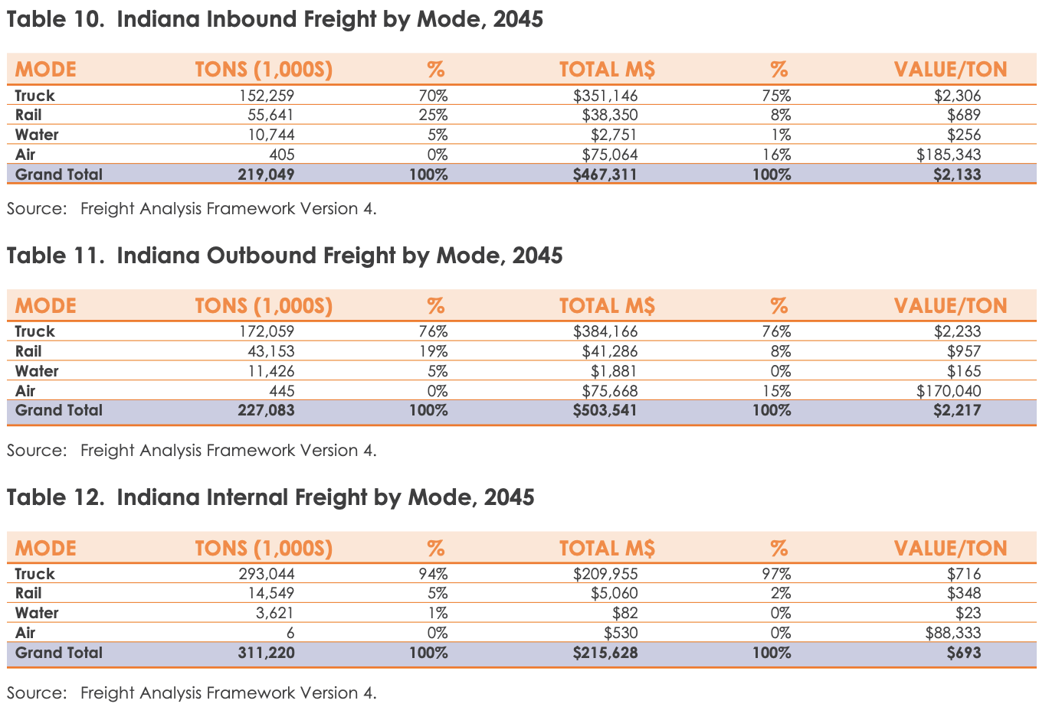

All of the above data convincingly show that both the size and trends of our two markets are sufficient in providing a compelling business environment for Men of Steel to launch and sustainably grow well into the future.

COMPETITION

At this time, we believe that our novel approach to train parolees and economically disadvantaged people to become truck drivers makes us uniquely-positioned to penetrate our target market and gain traction. That said, there are several traditional competitors operating in Indiana noted in the table below.

Name | Website
160 Driving Academy | https://www.160drivingacademy.com/
C1 Truck Driver Training | https://www.c1training.com/
CDL Xpress Training | https://www.cdlxpress.com/
Ivy Tech Community College | https://www.ivytech.edu/index.html
Indiana CDL Training Center | https://www.indianacdltc.com/
KLLM Training Academy | https://www.kllm.com/academy/midwest/
Safe Drivers Institute of America | https://www.safedriversinstituteofamerica.com/
Summit Commercial Driver Training | https://www.summitcdt.com/
Truck Driver Institute | https://www.drivebigtrucks.com/
Wagler Education | https://www.waglereducation.com/

Men of Steel will implement competitive strategies to create an inviting path for newcomers to enter the market by working with us while we win customers from these established companies. (See Sales & Marketing and Operating Plans below.)

SALES AND MARKETING PLAN

SALES

As noted in our Market Analysis above, Men of Steel sells into two markets:

- Prospective Driver-Partners comprised of men (primarily) either on parole or facing serious economic circumstances.
- Shipping Customers in the local community.

The mission of Men of Steel is to offer our prospective Driver-Partners “free” training to become actual truck drivers. Thus, we will not expect these students to cover the costs of their training. Rather, we will seek available job-training funds and other grants and donations from nearby public and private sources to support each student.

Importantly, we will work with local shippers to hire us and our students-in-training as an additional and key source of revenue. This revenue will not just help cover the costs of the training but also aid us in building our school so we can expand and help more students become drivers in the future.

We will employ the Marketing strategy outlined below to attract students and paying customers. As for actual student enrollments and customer sales we will establish our website to handle those processes complemented by the personal touch of phone and email outreach by our founder and a small sales team.

- Revenue Model
Our revenue model to support our students and operate our Driving School is two-pronged:

- Grants, scholarships, and donations from the local community;
- Contract revenue from local shippers for our trucking services.

- Rollout

We anticipate the following timing to launch Men of Steel.

- Planning: November – December 2021
- Fundraising: January – April 2022
- Start Operations: June 2022

- Business Development & Sales Processes

The key to driving sales and growing Men of Steel is in the creation and management of a sales pipeline of all of our potential students and shipping customers. We will utilize these software tools below, or similar software, in this effort as appropriate.

  - Pipedrive (https://www.pipedrive.com/)
We utilize this sales tool to identify, organize, prospect, follow-up, and close targeted student populations and customers This high-value, low-cost tool will aid us in identifying and tracking sales leads, thus enabling us to jumpstart sales and move into the next phases of growth.

  - Mailchimp (or similar) (https://mailchimp.com/)
In order to establish ourselves in our space, which will attract interest and lead to increased enrollment and revenues, we will regularly send out thought pieces and value-added campaigns to current and potential students, customers, partners, and influencers. This will aid us in our sales efforts by being top of mind among potential customers in our targeted markets.

MARKETING

As with any new venture, attracting interest from our target customers, driver-partners and shipping customers, is vital to getting enrollments and generating revenues. We will employ various marketing strategies to reach and engage both markets. (See Market Analysis above.)

Driver-Partners
Primary Objective: We must first find candidates to enroll in our training school and become driver-partners. We then need to build trust and show these candidates the benefits of joining our program. We will start in our home base of Fort Wayne, IN and only after solidly establishing and operating the venture will we look to expand to Chicago and Detroit (see above in Market Analysis for more details.)

Strategies:
- Event Marketing
We will host fun open houses/drop-in events at our training facility with food and entertainment (donated) for candidates and their loved ones to attend so we can establish goodwill and introduce the value of being trained by Men of Steel.

- Website
Our website is will serve as our primary marketing and communications hub through which we will:

  - Provide a clear and compelling overview of our training services and value proposition;
  - Gather information and inquiries from potential students;
  - Collect emails and contact information to populate our sales database within Pipedrive.
  - We will eventually provide the functionality for candidates to enroll in the school on the website.

- Social Media
We will establish a company Facebook Page and join relevant Facebook groups to find potential students.

- Local Media
We will reach out to the local press and media outlets to do stories about Men of Steel and promote our website and location.

- Local Partnerships
We will approach various public and private community organizations to introduce Men of Steel and invite them to refer candidates to us for enrollment.
For example:
- Correctional (Probation/Parole) Offices
- Salvation Army and the like
- AA/NA/AL-Anon groups
- Workshops and job fairs conducted by local government

Shipping Customers
Primary Objective: We will engage local shipping customers to hire Men of Steel and our students to haul their freight as part of our training program. As with our Driver-Partners, establishing our services as reliable, trustworthy, and high-quality will be critical to building our reputation and gaining contracts.

Strategies:
- Event Marketing
From time-to-time we will invite shipping customers to our driver-partner open house events and training classes so they can meet and mingle with our Men of Steel students and see for themselves the quality of our program.

- Website
Our website is will serve as our primary marketing and communications hub through which we will:

  - Provide a clear and compelling overview of our shipping services and novel operating model;
  - Gather information and inquiries from potential customers;
  - Collect emails and contact information to populate our sales database within Pipedrive.
  - We will eventually provide the functionality for shippers to start the contract process on the website.

- Local Media
We will reach out to the local press and media outlets to highlight the companies, with their permission, who are hiring Men of Steel.

- Direct Marketing
We will identify and create a database (Pipedrive) of potential customers in the area and start to approach them consistently. We will especially take care to identify the appropriate contacts within these organizations including the offices of Community Relations, Communications and Marketing, and any Foundation/Charitable arm related to the company.

OPERATING PLAN

Men of Steel, at its core, is a transformational driver training company with a unique hiring and training model that serves those who lack a second chance at change.

The core of Men of Steel operations will focus on:

- Student Recruitment
- Driver-Partner Training
- Shipping Customer Development and Management

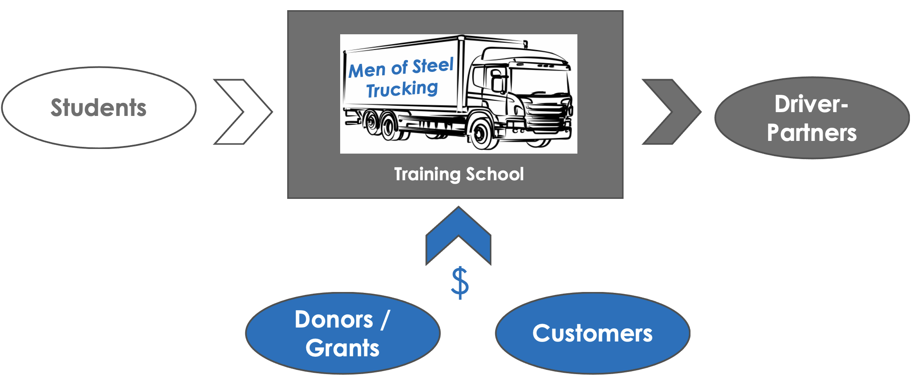

Student Recruitment

The sole mission of Men of Steel is to assist in the transformation of people desiring to overcome bad choices and painful circumstances and become something more, to provide a second chance at creating healthier and more productive lives. Recruiting and enrolling students, future Driver-Partners, into our school is job one.

Initially, this effort will be led by our Founder, Mr. Garnett. He will utilize the strategies put forth in the Sales & Marketing Plans above. As these strategies yield results, students will be enrolled in upcoming classes at Men of Steel. The enrollment process will be paper-based at first but then quickly convert to a web-based process as the website is built.

Once a threshold of 15-20 student enrollments has been met, Mr. Garnett will engage a reliable and competent partner/employee to assist in the ongoing, longer-term recruiting efforts so that Mr. Garnett will have capacity to develop and run the actual training program for our Driver-Partners.

Driver-Partner Training

Operationally it is imperative that we secure a central location and quality facility for our school. The cost of this will be addressed in our Financial Plan.

Once we know where the school will be and what our student capacity is we can finalize enrollment for our first class. And as enrollment in Men of Steel grows, we will carefully add instructors and staff to conduct the training and handle operational matters at the school. For now, however, at launch and as we grow in the initial phases Mr. Garnett will be the primary instructor and mentor to our first students. Not only will this keep costs down but will also ensure that we build a solid foundation and identify and address potential and actual problems proactively. This way, when we add additional team members, we will be able to transition more smoothly.

A course outline, class content, and overall schedule will be developed right away so that each enrolled and prospective student will know their path forward and what the commitment will be. This will ensure transparency, communication, and steady and reliable progress toward graduation and eventual placement into permanent jobs.

A critical part of our course content will include the all-important element of actual driving. This is where we set ourselves apart with our novel approach to training by working with actual shipping customers (see next section) who allow us to do local shipments for them in exchange for either a tax-deductible donation or heavily-discounted rates vs. the prevailing market.

As our students graduate, we will look for opportunities to place them as paid staff of Men of Steel as instructors or admin support for the school and/or permanent drivers for our shipping business. Doing so will enable us to provide loyal, well-trained partners to assist in the growth and success of Men of Steel.

One additional feature we are exploring at this time is to provide affordable housing arrangements near the school in Ft. Wayne for out-of-town students who will benefit not just from attending Men of Steel but also from getting out of the cities where they live in which many of their problems and bad influences still exist and serve as impediments to change. In this way, Men of Steel better fulfills its vital mission of providing a second chance with fresh, realistic prospects for transformational change.

Shipping Customer Development and Management

Once we have students, eager to change their lives and become successful Driver-Partners, we then need actual shipping customers to make our model work. Developing these potential customers will be another high operational priority. Mr. Garnett will also lead this effort initially and leverage the network of contacts he has built in his decade of trucking experience.

These potential customers will be offered either a tax-deduction for a donation to the nonprofit entity we may form or steeply discounted rates in exchange for allowing us to ship their freight as part of our training process. Men of Steel will provide close oversight of our students, prudently chosen to handle these shipments as part of their training.

Closely coordinating the relationships with these customers will be of great importance and carefully managed by Mr. Garnett well into the growth and expansion of Men of Steel, even as other partners/staff may be ready to assist.

In addition to the core of our operations we will ensure that the other essential elements of operating a successful business are handled effectively: finance, legal, and administration, including HR functions.

OWNERSHIP & MANAGEMENT PLAN

Men of Steel is founded and solely owned by CEO, Matthew Garnett. At this time, Mr. Garnett and his advisors are exploring the best legal structure of the entity and whether to form a for-profit or a nonprofit company. We are assessing whether a for-profit entity with a social mission is a more efficient structure than a standard nonprofit entity.

Fundamentally, the ownership of Men of Steel will be determined by the belief that meeting the capital needs of the company is best accomplished by investing the revenues generated from the company’s customers and strategic partners back into the company. And, regardless of which company structure we use we believe that the expansion of ownership to select financial backers will positively impact the company’s ability to grow the reach of its mission. And then the company will seek only to employ the most financially efficient forms of capital and most ideal terms that contribute to the longevity of the venture.

MANAGEMENT

As Men of Steel proves its business concept and begins to successfully expand its business, the management team will be expanded with strong operators. For now, Mr. Garnett will strategically employ advisors, potential partners, and consultants to assist him with this phase of the firm’s development.

Founder and CEO-Matthew Garnett
For 30 years Mr. Garnett has worked in a few impactful industries from trucking, most recently, to customer service and operations management, to religious ministry. With this solid and broad foundation, Mr. Garnett is optimally-positioned to transition to a full-time role leading Men of Steel and working one-one-one with its students and customers who will support their training. His practical know-how as a driver with strong focus on serving customers alongside understanding of what makes people tick and how to motivate change within them will prove to be key determinants to the success of the venture.
Mr. Garnett explains the drive behind executing his vision as follows:
“My motivation is twofold.
My foundational motivation is to pull people out of impossible situations into more hopeful ones. Trucking, while a very hard and demanding job, is a very easy career to enter. My bet is that my program will be perfect for former inmates. It will give them the structure they need coming out of prison and a clear vision for their future.
The same applies to underprivileged youth. Many times, these kids simply don’t believe there’s any other way to live other than to gang-bang or engage in criminal behavior unless they become a professional athlete or entertainer, which rarely happens. If we can get just a few of them to embrace this program and find a way forward, others will follow as well.
My other motivation is to show, like other companies have, that doing a project like this in a market-based economy can work. With the massive shortage of skilled tradesmen in the US (especially truckers), I believe our school will prove to be a source of untapped resources. Most established companies aren’t willing to take the risk or put in the investment in something like this for various reasons. If these guys can prove themselves in my program, then they can move on to more mainstream avenues of employment all while I’m able to keep a trucking company afloat.”

FINANCIAL PLAN

As addressed above in the Sales Plan and Ownership Plan sections, Men of Steel will balance its sales results and capital needs in ascertaining the need for outside capital, be it debt or equity, with a bias toward self-funding by investing revenues back into the company.

Accordingly, we will generate and grow our revenues by using a phased-in approach with multiple streams of income and establish access to a range of capital sources vital to our operating needs.

We have created pro forma financial projections (see Appendix A) for the next five years which will serve as a roadmap to assist us in operating in a way that prioritizes the essential steps to get on and stay on our best path forward to maximize the chances for long-term success.

At this time, we are seeking $400,000 in an unsecured loan or grant to quickly launch operations and grow.

We will allocate this capital as follows:

- Equipment purchase
- Personnel
- Website Development
- Marketing and Advertising

EXIT STRATEGY

After 5-7 years of successful operations and proven growth, we expect to be able to sell the company to a larger acquirer.

KEY METRICS

Our key financial metrics for the next five years of growth are:

- ~$500K in Income by 2022-end
- Breakeven by year-end 2024
- $2MM+ in Sales by 2024
- $1mm+ in owners’ Equity by 2025

APPENDIX A

https://www.prisonpolicy.org/reports/correctionalcontrol2018_data_appendix.html
http://www.allencountycorrections.org/pdfs/reports/2019ACCCandACAPAnnualReportFinal.pdf
https://www.azuga.com/blog/latest-trucking-industry-data-2021
https://www.businessinsider.com/us-needs-truckers-trucking-association-president-says-2021-10
https://www.in.gov/indot/files/Indiana%202018%20State%20Freight%20Plan.pdf
https://www.in.gov/bmv/licenses-permits-ids/files/truck-driver-training-schools.pdf

